Beyond the Suggestion Box:
Coming Together to Improve Resident/Tenant Quality of Life

In early 2019, we set out to create “Community Advisory Boards (CABs)” designed as joint conversations with assisted living leadership and residents/tenants. The idea was that these newly created community advisory boards would generate opportunities to co-design how supportive care is delivered and to improve tenant’s safety and quality of life. The project explored new ways to jointly brainstorm and bring forth innovative solutions for long-standing issues in communities.

We took the following steps at this project’s outset to create a new and improved model for joint decision-making and problem solving:
- Literature and white paper review
- Leadership meeting observations and 1:1 interviews
- Resident/Tenant Council in-person observations and focus groups
- A design day with all stakeholders invited to brainstorm effective elements for community advisory boards
- Host pilot Community Advisory Board Meetings

Soon after the conclusion of a first round of Community Advisory Board pilots and meetings, safety precautions due to the global COVID-19 pandemic prohibited further in-person meetings and councils to take place. Each site piloted at least one Community Advisory Board. Despite the project discontinuing due to COVID-19 safety precautions, early project learnings demonstrated that partnering at this level created a clear pathway for infusing tenant and family voices into the delivery of care services and the assisted living community.

Leaders at pilot sites we worked with stated this was a novel and valuable way to work alongside residents/tenants. Residents and tenants found excitement, meaning, and purpose to be included. Since CABs are a new way to co-design with residents/tenants, coaching from the MAPS team or other communities could accelerate success as you launch.

This report summarizes learnings and informs new and possible ways to bring the resident/tenant voice into organizational problem-solving and decision-making. This project was led by the Minnesota Alliance for Patient Safety (MAPS) and involved three pilot assisted living facilities in MN. The project was funded by Care Providers of Minnesota and the Stratis Health Building Healthier Communities Fund.
What is Engagement:
Family and resident engagement means that families and residents are involved in activities intended to enhance quality of life, quality of care and safety for residents.

The following are more traditional ways that assisted living communities declare they may invite tenant input and communication:
- Admission and intake process into the community
- Surveys
- Formal Complaint process
- Suggestion or concern box or form
- Newsletters
- Existing tenant and resident councils
- Leadership update meetings

While helpful, we believe there are additional effective and meaningful opportunities to have two-way conversations with tenants/families. The options listed above are common and necessary at times, but typically not the most effective method to garner genuine engagement of those you serve.

It requires a shift in leadership thinking from making decisions “FOR” tenants to making decisions “WITH” tenants. Oftentimes with the methods listed above, leaders are still left to make assumptions about what is needed or wanted, or other factors for which either stakeholder group may be unwilling or unable to share their opinions. Conversely, inviting tenants and families for first-hand, two-way conversations about their experiences brings more genuine input.

“Those things designed for us, without us, are not for us.”
-Rohit Malhotra, Founder and Executive Director, Center for Civic Innovation

Why Does Engagement Matter?
In Minnesota, adverse resident/tenant outcomes, media reports, and significant legislative changes indicated a lack of robust opportunities for engagement, joint decision-making, and communication that help ensure decisions in assisted living regarding facility environments and care service delivery better include and reflect the tenant and family perspective and needs.

We focus on true engagement with those we serve because we know it leads to:
- Better clinical outcomes
- Improvements in safety and quality
- Better resident experiences and satisfaction
- Increased healthcare professional satisfaction and retention.
- Lower healthcare costs
In a newly released national action plan to improve safety across the care continuum, “Safer Together A National Action Plan to Advance Patient Safety,” engagement is identified as a critical in order to improve safety. The report states, “The authentic engagement of patients, families, and care partners is essential for improving safety, and there is a growing evidence base of innovations that are effective in improving patient and family engagement and improving patient outcomes.” The report recognizes that the use of the term “patient” does not always resonate. Striving for person-centered care is the ultimate goal. However, in the National Action Plan, the narrower term “patient” is used for simplicity.
Under the larger category of Patient/Family Engagement, several national goals directly relate to this project, namely the following recommendations:
- Recommendation 6. Engage patients, families, and care partners in the co-production of care. Health care leaders and health care professionals need to fully engage with patients, families, and care partners in ongoing co-design and co-production of their care.
- Recommendation 7. Include patients, families, and care partners in leadership, governance, and safety and improvement efforts. Health care leaders and governance bodies need to involve patients, families, and care partners from all backgrounds in health care oversight, design, and improvement, as well as harm reduction efforts.
We strongly encourage assisted living leadership and management review this national action plan and details about these goals for additional information on the importance of engagement, particularly for safety.
Nationally, there is a lack of robust and innovative assisted living engagement practices from which to draw from as well as a scarcity of evidenced-based research available for implementation. The recommendations in the National Action Plan do provide tactics, of which we are proud to say the Community Advisory Boards described here are one effective way to meet the goals. Many of these tactics serve to build stronger relationships of respect and trust between leadership, residents/tenants, and families. Simply, including residents/tenants, families, and care partners is the right thing to do in every place decisions are made regarding their community and their care.

“Alone we can do so little. Together we can do so much.”
-Helen Keller

Introducing Our Pilot Concept: Community Advisory Boards
During 2019, we worked with three pilot Assisted Living Communities, one each from urban, suburban, and rural areas. Over the course of a year, we had several in-person visits in which to conduct observations of Leadership meetings and resident/tenant councils. We also conducted interviews with leaders and focus groups with residents. Lastly, we administered surveys to glean individual perspectives regarding engagement. All of these activities were in an effort to plan for Community Advisory Board pilots.

Interviews, Observations, and Focus Groups
We made multiple site visits with our three pilot sites. On-site, we observed leadership meetings as well as resident/tenant councils. We conducted 1:1 interviews with leaders and focus groups with residents/tenants. To guide our visits, we adapted information and questionnaires from the Agency for Healthcare Research and Quality “Working With Patient and Families as Advisors Implementation Handbook.” The following are key themes from these activities.

Leadership Topics:
Three was a lack of awareness on behalf of leadership teams of the positive impact and influence that tenant and resident input can have on operational decision-making. Notably, this is not a local issue, there is a nationwide lack of role model and example assisted living communities doing work this way.

In terms of response to more traditional methods of seeking input (e.g. surveys, suggestion box), tenants and residents expressed they may not see or be aware of leader’s follow-up, even if it did occur. Leaders acknowledged that follow-up may not be widely communicated or could be delayed. Leaders expressed that many traditional avenues for input are not efficient for families, may feel “clunky,” or always end up on the “back burner.” They noted families would often state that is perceived their feedback goes into a “black hole.”

Leaders expressed that progress on issues may realistically take longer than residents’ expectations and didn’t always have time for on-going updates or communication. Lastly, there was a sense that tenant and resident visibility into complex issues of the facility may be limited, sometimes due to required and appropriate confidentiality constraints.

Overall, leaders expressed genuine care and concern for the health, wellbeing and safety of those in their community. Many stated their greatest leadership joy is found in time with residents and tenants. They have a strong desire for residents and tenants to “live their best life” and succeed (e.g. in trying new activities).

There is a willingness to try to more meaningfully and deeply embed the concepts discussed on engagement best practices and partnership with acknowledge it would be different from traditional ways of leading. There is a desire to be transparent with residents and tenants, particularly with performance improvement data. All those we spoke with subscribed to an “open door policy” and want strong communication with residents and families.

Stated challenges to including residents and tenants at decision-making meetings and functions include:
  - Privacy and confidentiality of other residents.
  - Inviting those to participate, but perhaps cognitive or physical decline may impede participation in the future—and that’s a hard conversation to have—particularly if the resident or tenant wants to continue and loves the work.
  - Fear that residents and tenants could ask for things that are too expensive or not feasible, and we’d need to say no or decline the request.
  - Expressed the hardship of constrained resources and increased administrative burdens prevent them from this type of work, particularly increased documentation and paperwork, that already takes away from time with residents.

Resident/Tenant Topics:
At times, residents were affected by medical, physical, or cognitive condition limitations, prohibiting and/or challenging effective facilitation and/or participation. Coincidentally, this was the most common cited challenge by leadership in our project.

Residents and Tenants acknowledged that successful conversations could be often impeded by social and relationship dynamics of the resident/tenants. For example, some personalities are very vocal and opinionated, or certain “cliques” and peer pressures existed and prevent all participants from safely speaking up.

In regard to attitudes towards leaders and staff, all residents expressed sincere gratitude and appreciation for staff who are thorough, respectful, kind, and provide time and attention (particularly attention to small details related to tidiness or interest in personal lives). All universally appreciated the activities leader, there were many housekeeping compliments, and typically mentioned 1-2 people in the kitchen by name they could “count on.”

They were unclear about the kind of authority or credibility that they, the residents, have with management team members. They frequently expressed wanting to be more involved in how decisions are made. They had a desire to learn more and have an explanation about how decisions in their community are made and by whom. They sought a better understanding of when and how to expect management responses for submitted or discussed issues. Residents could perhaps benefit from understanding:
  - Various roles in the facility (what can a personal care assistant do and not do?)?
  - Helpful to understand staff members training or background
  - Who can make decisions, and structure of the management team (e.g. get to know your leaders…”)

When possible, they wanted more avenues for their family involvement. They strong and nearly unanimously expressed a sense that family involvement was more impactful than their own personal requests to staff and management.

The most discussed topics that residents wanted to be a part of with management included:
  - Pendant and call light response times; with an underlying fear of not getting help when needed
  - A sense that management provides an answer that “we’ll check into it,” or “we’ll get back to you on that” and the closed loop rarely happens
  - What they perceive as “a big deal,” management does not (e.g. environment and maintenance requests being completed timely or thoroughly)
  - A lack of confidence in appropriate guidance and leadership of frontline staff; expressed inconsistencies in practice of staff in same roles
  - Easier or more accessible ways to carry out or get engaged with personal interests
  - Leadership and management does not accept or explain food request suggestions and/or denials

Overwhelmingly, the most important aspect of the assisted living community to the residents was the connection, sense of community, and care they have for their neighbors and friends in the community. They want everyone to be safe, secure, and personally fulfilled. They highly valued staff accessibility, approachability, and team members genuinely taking interest. Last but not least, they want to be able to fulfill their own personal sense of purpose, and having degrees of autonomy and independence.

Current Resident/Tenant Council and Committee Functioning:
Occasionally observed in the resident/tenant councils, there was a lack of awareness or adherence to generally accepted meeting etiquette and effective meeting processes, particularly for solely resident-run councils. At existing councils, there were observations of unfocused conversation and problem-solving was sometimes “all over the board.” Tenants and resident participants often describe that their peers may use the resident council only as a means for complaint discussion.

If it was invited, there is a shortage of resources within leadership teams of how to coach and co-design an effective tenant and/or family council alongside their residents.

If leadership is in attendance, the conversation may not be an equal exchange of information or ideas as there was a natural tendency for leaders to more wholly control and facilitate the conversation. Additionally, residents did express occasional feelings of intimidation not to speak up in front of leaders about true concerns or perceived issues.

Survey Results
We administered a survey across the three pilot sites that questioned perspectives regarding a sampling of known best practices for engagement. Survey responses between leadership and tenant groups showed several disparities regarding engagement perspectives.

Of note, 67% of Residents and Tenants strongly agreed/agreed they routinely offer ideas and suggestions to facility leadership compared to only 50% of leadership. Conversely, 67% of leaders strongly agreed/agreed there is effective communication with tenants compared to only 42% of tenants.

Community Advisory Board Pilots and Toolkit

A Community Advisory Board (CAB) has both leaders and residents/tenants present, in equal participation as much as possible, to discuss selected topics and make decisions together that affect our community. Depending on the topic, the community may even invite family members or other community partners.

CABs were to be designed to meet for events throughout the year to:
- discuss topics meaningful to both management and residents
- equally exchange ideas
- decide together on solutions to problems
- promote actions that everyone can own

A CAB is not:
- A replacement of a resident/tenant or family council. The community will maintain an independent resident/tenant or family council.

- A replacement of all leadership meetings. It is acknowledged that management will still need other meetings to plan and make decisions.

- Merely a community update meeting from management. This often is only a one-way communication that doesn’t include meaningful input for joint decision-making.

By launching Community Advisory Boards in assisted living, all stakeholders are invited to shape how care is delivered and improve tenants’ quality of life in assisted living settings.

The CAB Planning Meeting
The first step to a successful CAB is a planning meeting. A small group will come together (2, 4, or 6 individuals), comprised equally of leaders and residents/tenants, to plan the first Community Advisory Board event. The ultimate goal is to create a meaningful Community Advisory Board in the community. At the initial planning session, the group will take steps to:
- Select topics meaningful to the community
- Agree to basic details about how the CAB events will be designed
- Start to design the first event!

Before the first planning meeting, think about and gather observations from your community for idea topics for your first Community Advisory Board meeting. Choosing meaningful topics will help the CAB succeed. Start by simply brainstorming a big list (quantity over quality) and narrow it down. Questions to consider for possible topics:

- Is there an issue that comes up repeatedly in our resident/tenant council?
- Is there an issue that comes up repeatedly in staff satisfaction or resident satisfaction surveys?
- Is there a quality or performance measure for which we haven’t been able to reach the goal we want?
- What’s been an issue that creates gossip in our community?

Once a topic is selected, check it for the following characteristics:
- An important perspective is shared from both management and residents
- Something about our topic can be educational
- The topic has some sort of data or measurement information to share
- The topic can be further understood with a story or sharing an experience
- The topic lends itself to a decision to-be made, or action to happen
- Be able to clearly state why the topic matters to both the management and the resident/tenants

Topic Example: Emergency Pendant Call System
- Clarify the Why: start with, and clearly state why this topic matters to us.
- E.g. “the proper use and response for our emergency pendant call system continues to be a matter that is brought up in a variety of meetings. To ensure residents have the utmost confidence in our system and that our staff can respond timely to the urgent calls that require emergency assistance, we need to ensure the system is used and responded to correctly. A well-functioning system ensures everyone’s safety and respects everyone’s time.”
- Ask the group about the strengths and weaknesses of the system how it is designed today.
- Provide basic education on how the system works.
- Clarify basic pieces of information like, where do alerts go, who is expected to respond, the intended use of the system.
- Then, have a resident present a story or example perhaps where the response was excellent, or when it could have gone better
- Agree together on where education might be needed (e.g. residents understanding appropriate use, staff to know basic minimum response time or how to call for back-up)
- Create a list of potential solutions together to address the issues
- Agree to share call light/pendant response times transparently for the next 12 months for residents and families in an effort to solve the challenges together.

Other specific example topic ideas to expand on:
- Falls prevention, Medication error monitoring and reduction
- A day in the life of a resident or a personal care assistant
- Get to know your leadership team and staff roles/positions here
- The basics of effective communication for best care
- How our community can best support resident’s connecting to their purpose, or enhance their quality of life
- How we can best help our staff find joy in their work

Design the event details:
Deciding the meeting details ahead of time will make planning each event easier over time. Talk about:
- Invitees (who is invited). Those who plan the event should commit to attending. Additionally, we recommend any resident or tenant should be invited to the CAB meetings. In the future, you may consider other guests like families, contracted services, or other community partners depending on your topic.
- Location (where is it held)
- Frequency (how often to meet)
- Duration (how long is the meeting)
- Refreshments (do we serve refreshments)
- Event Promotion:
- formal invitations
- prizes
- social hours
- volunteer opportunities combined with this event

Having a consistent event will be important to set expectations, keep meetings on-task, and ensure event goals can be met.

A checklist for a successful first Community Advisory Board Event:

- Send the invitation 3-4 weeks in advance (see Appendix A)
- If you have multiple dates selected for the year, publish on an annual
calendar in a visible area. Include the location, timing, and if there will be refreshments
- Create a Pre-Event Survey (see Appendix B); pay particular attention to asking for ideas for improvement
- Create an Agenda (see Appendix C)
- List the topic to be discussed. Decide if there is only to be discussion, or if
there is to be an action taken. If so, try to include any decisions to be
made and think about if a vote is necessary
- List the names of any speakers
- Include any data that may be shared -- including pre-survey results!
- Start the meeting with a moment of positivity, gratitude, or safety-for
example:
- What is one thing that makes you feel safe here?
    - Is there a resident or staff member you’d like to recognize for going the extra mile to help a resident?
- If the size of your group allows, include a way or exercise where every attendee must speak-up or say something
- E.g. a round robin icebreaker to kick-off the meeting, like “what was a favorite childhood game you played?” or a way to end the meeting like “what is one important take-away you have from this meeting?”
- Create Meeting Etiquette Guidelines
- Everyone can agree to and sign off on as they enter the room.
- See sample starting set in Appendix D

Appendix A: Three Sample CAB Invitations
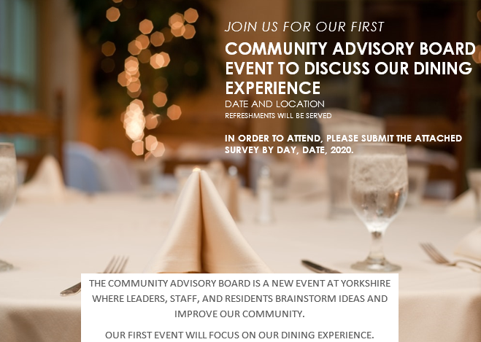

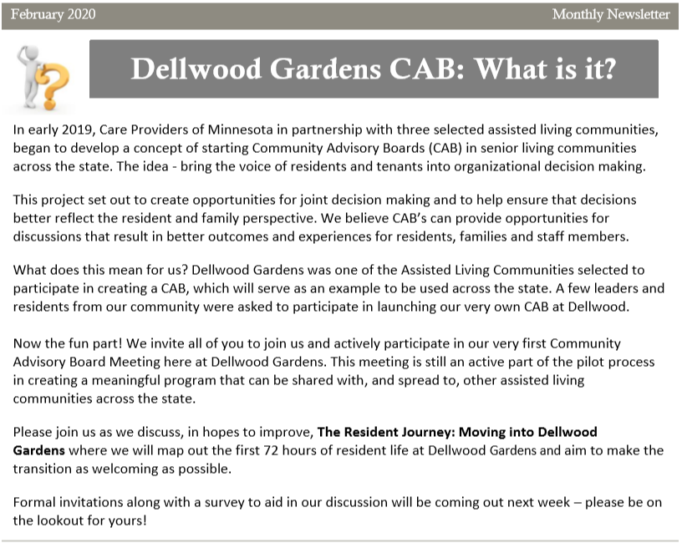

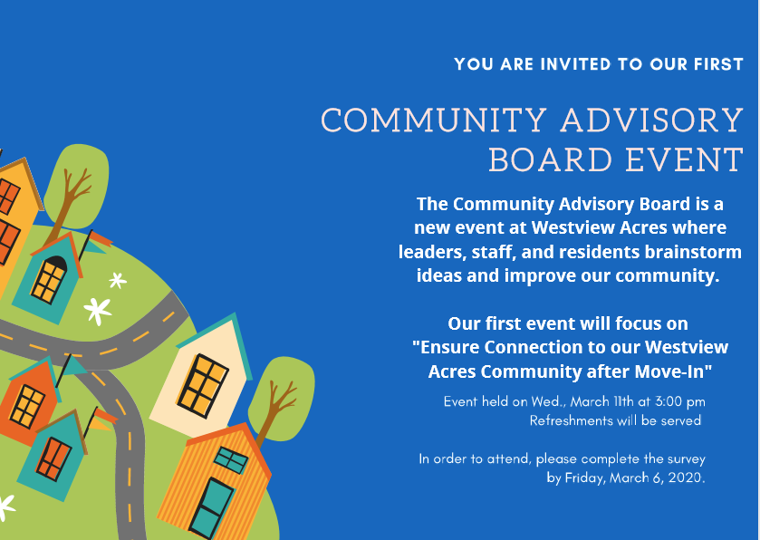

Appendix B: Sample Pre-Surveys

Pre-survey for Community Advisory Board event.

In order to attend, please complete the survey by Friday, March Xth, 20XX and give to Rebecca in the Campus Relations office. The first 30 responses will be able to attend. Rebecca will let you know if you are one of these first 30.

"Ensure Connection to our Community after Move-In"

How did you feel welcomed and connected to our community when you moved in?

____________________________________________________________________________________________________________________________________________________________________________________

Did you experience loneliness after moving in? (check your answer)

YES NO

What was the hardest time for you after moving in? (check your answer)

1st week 1st month At around 2-3 months

Name 3 ways we create a more welcoming environment after a move-in

1.

2.

3.

PRE-SURVEY FOR COMMUNITY ADVISORY BOARD EVENT TO DISCUSS OUR DINING EXPERIENCE
Please return this survey by XX/XX to…

For this discussion, we’re focused on the how residents are seated, when meals are served, and how residents return to their rooms or common areas. Please reserve any comments about the food options or quality itself for our “Coffee with the Chef” meetings.

What do you like most about the dining experience here at Yorkshire?
____________________________________________________________________________________________________________________________________________________________________________________

What are 1-3 things you’d like to improve?
1.
2.
3.

What are your ideas to improve them?

Appendix C: Sample CAB First Meeting Agenda
*Note Include Pre-Survey Results

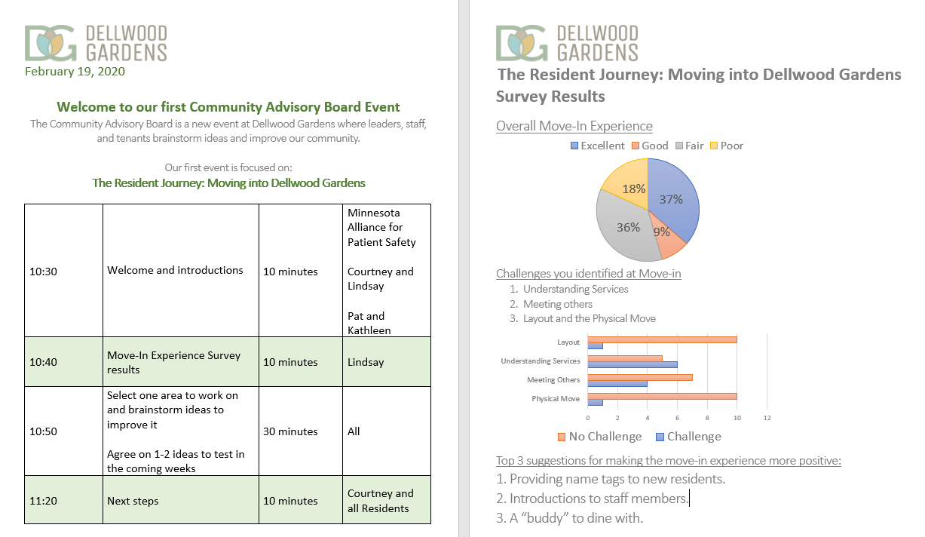

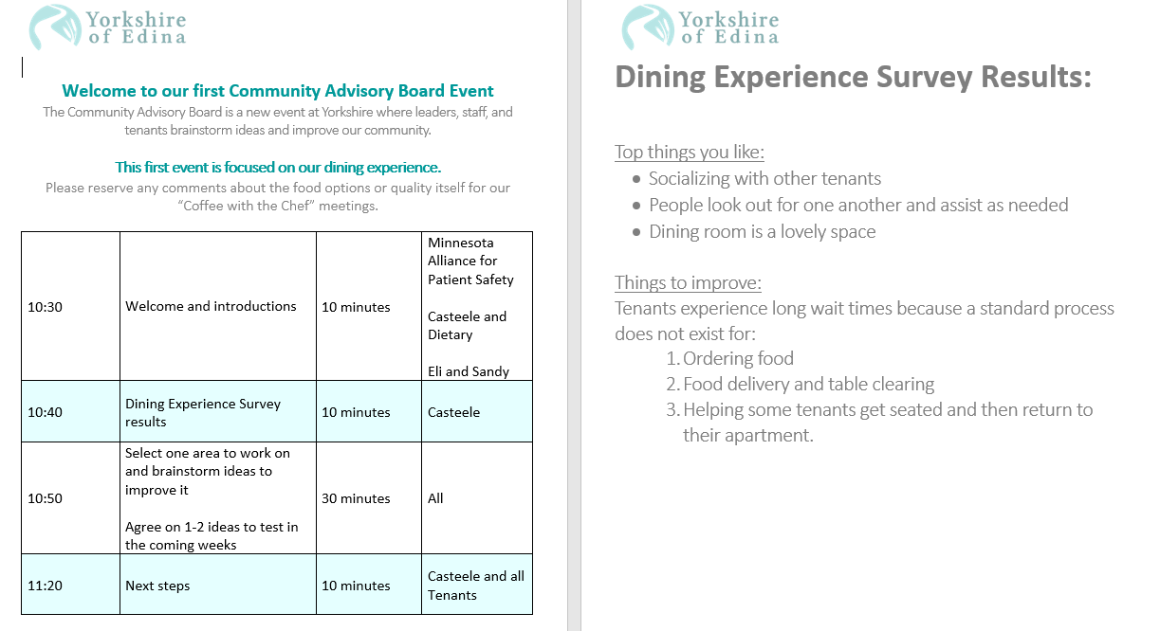

Appendix D: Sample Meeting Etiquette Guidelines

Meeting Agreements
How can I effectively participate?
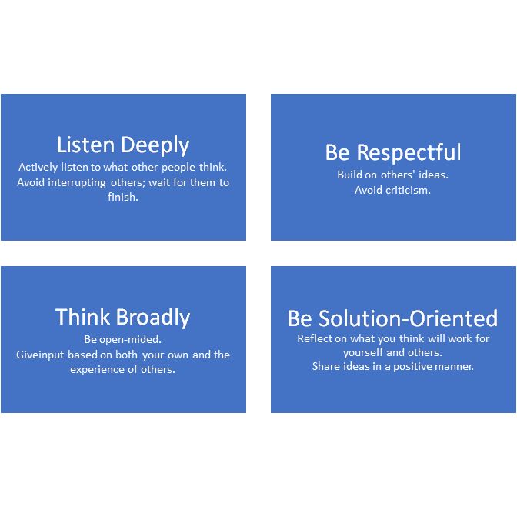
Adapted from Patient-Centered Primary Care Collaborative and Institute for Patient and Family-Centered Care

https://www.cms.gov/Medicare/Provider-Enrollment-and-Certification/QAPI/Downloads/QAPI-Consumer-Factsheet.pdf
National Steering Committee for Patient Safety. Safer Together: A National Action Plan to Advance Patient Safety. Boston, Massachusetts: Institute for Healthcare Improvement; 2020. (Available at www.ihi.org/SafetyActionPlan)
Strategy 1: Working With Patients and Families as Advisors. Content last reviewed December 2017. Agency for Healthcare Research and Quality, Rockville, MD. https://www.ahrq.gov/patient-safety/patients-families/engagingfamilies/strategy1/index.html

